Outputs:

1. Output for pgm1:

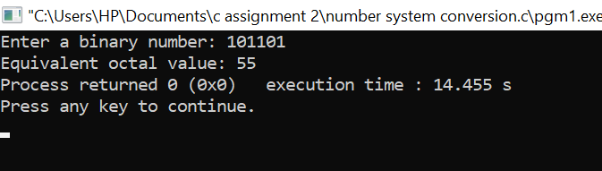

1. Output for pgm2:

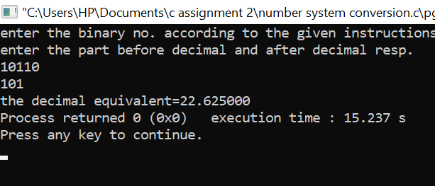

1. Output for pgm3:

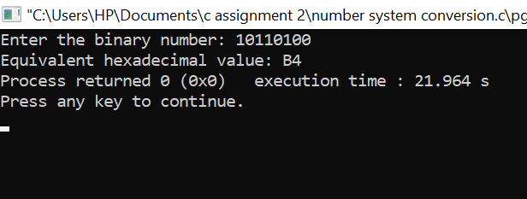

1. Output for pgm4:

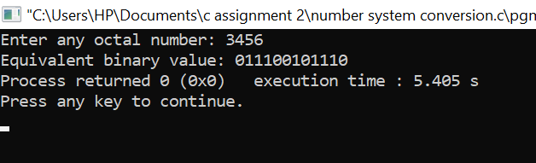

1. Output for pgm5:

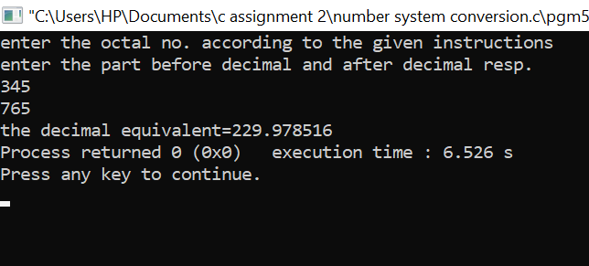

1. Output for pgm6:

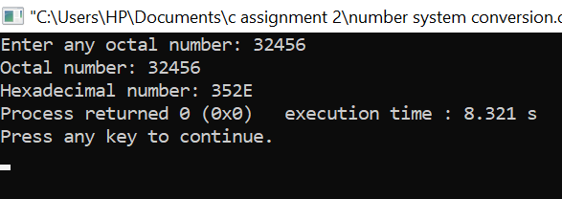

1. Output for pgm7:

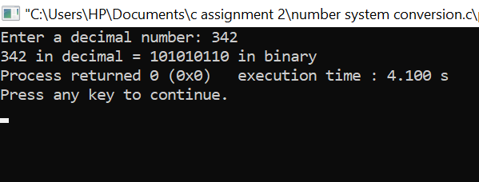

1. Output for pgm8:

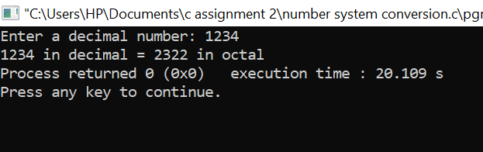

1. Output for pgm9:

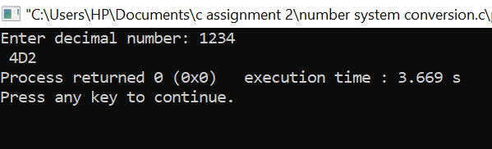

1. Output for pgm10:

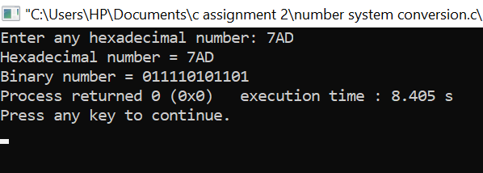

1. Output for pgm11:

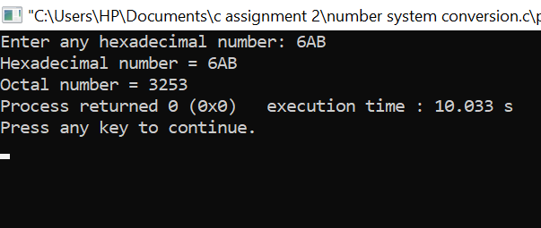

1. Output for pgm12:

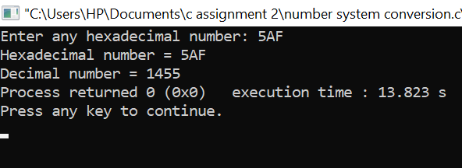

Thank you!!!